Build a Laucher for yourselves
We can create a shortcut; thus, we can directly go into the environment we want, also the target folder where we will always work. Now our goal is to write a command line like following below:
%WINDIR%\System32\cmd.exe /k "call D:\Programming\Anaconda\Scripts\activate.bat BCI_seminar && cd /d C:\Users\yevge\Desktop\BCI_py\Student && jupyter notebook"

right click on Anaconda Prompt Open file Location Target Copy the command here:
Example:
%WINDIR%\System32\cmd.exe "/K" D:\Programming\Anaconda\Scripts\activate.bat D:\Programming\Anaconda
Extract the parts you need and write the grammar like the example command line. Add environment name, and your working directory, at the end type jupyter notebook. Don’t forget the connecting parts and quote and back quote sign. Then you get:

Creating short-cut:
Open your working folder right click New Shortcutcopy the command line aboveName your short cut (like “Seminar_laucher”)
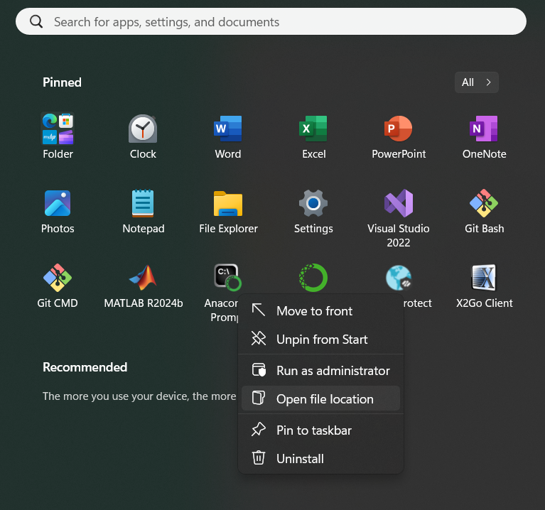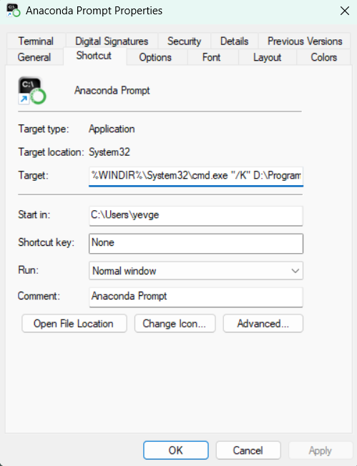

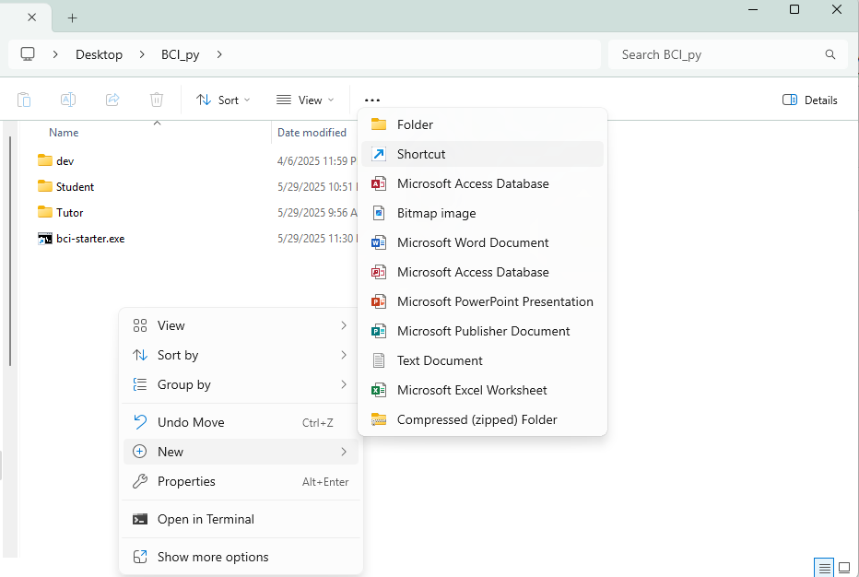

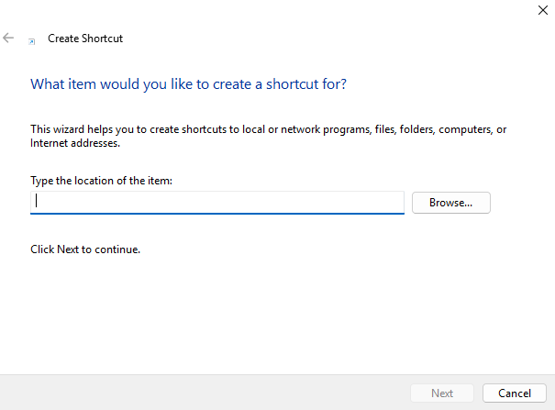
%WINDIR%\System32\cmd.exe /k "call D:\Programming\Anaconda\Scripts\activate.bat base && cd /d C:\Users\yevge\Desktop\BCI_py\Student && jupyter notebook"

%WINDIR%\System32\cmd.exe "/K" D:\Programming\Anaconda\Scripts\activate.bat D:\Programming\Anaconda

